File Spec and Samples

Payment Type | File Spesification | Sample Files
Priority Payment  For ISO 20022 preparation, please ensure to populate at least Town name and Country on your Debtor and Creditor postal address tagline |  | 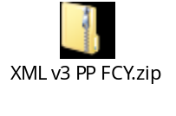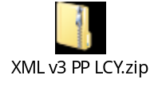
ACH Payment  Note :  ACH Payment is only for Salary/Payroll payment. | 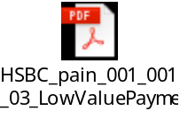 | 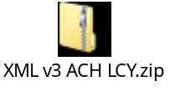
BI-FAST / Real time payment  For IDR currency only  Maximum amount for each transaction : 250,000,000 IDR  Please use Beneficiary Bank swift code ( BIC ) instead of bank clearing code ( use 8 digits Swift code without XXX ) as per list attached ( SWIFT-BIC RTP as of 7 May 2024.xlsx  Please also note “future dated” feature is not supported for BI-FAST ( File level and Pre-Auth ) | Mandatory field that need to be adjusted when using BI Fast / RTP payment type.  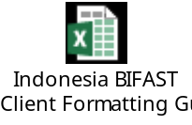  Please note BI Fast is NEW payment type introduced by our central Bank for Real Time Payment  BI Fast Comparison Guide (SKN VS RTP)  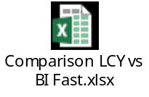  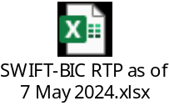 | Non proxy ( account number ) :  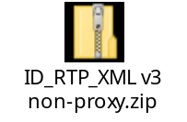  With proxy ( Mobile Phone number ):  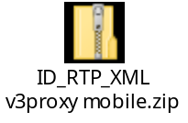  With proxy Email address :  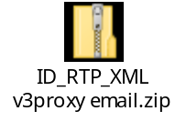  With proxy Email address ( LONG Email address ) :  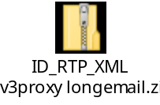

- IDR Regulatory Reporting

This information is Indonesia mandatory regulatory for any IDR payment. This information is depends on beneficiary characteristics. The masking for numerical value is /SKN/[Beneficiary Type][Beneficiary Status] where:

Beneficiary Type: | Beneficiary Status:
1 = Individual  2 = Corporate  3 = Government | 1 = Resident  2 = Non-Resident

In XML V3 payment file tagline, this information located in below tagline :

<Cdtr>
<Id>
<OrgId>
<Othr>
<Id>.</Id>
<Issr>/SKN/[Beneficiary Type][Beneficiary Status]</Issr>
</Othr>
</OrgId>
</Id>
</Cdtr>

*Please noted that full structure of <Id>.</Id> above must be provided. please use dummy value (e.g. <Id>.</Id>) instead of blank value

- IDR BI-FAST Regulatory Reporting

This information is Indonesia mandatory regulatory for BI-FAST payment. This information is depends on category purpose code and clearing channel..

Populate '/CPC/XX' where possible proxy code values for ‘XX’ are:
01 – Investment
02 – transfer of wealth
03 – purchase
99 – Others



For XML V3 we need to populate URNS as the clearing channel.

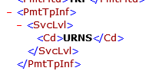

Indonesia Regulatory Reporting

- Non-IDR (Foreign Currency) Regulatory Reporting

The structure sequence for Indonesia Foreign Currency Regulatory Reporting is FXRWWXXZZZY.

Please find the details of each masking refer to below table :

Masking | Information | XML V3 Tag | Sample XML V3 Tag | Meaning*
FXR | No need to be defined in payment file
WW | Beneficiary country of residence | <Cdtr> <CtryOfRes>WW</CtryOfRes> | <Cdtr> <CtryOfRes>MC</CtryOfRes> | The beneficiary resides in “Monaco”
XX | Beneficiary category | <RgltryRptg> <Dtls> <Tp>XXY</Tp> | <RgltryRptg> <Dtls> <Tp>E0N</Tp> | The beneficiary category is “Corporate”
Y | Beneficiary affiliation status | <RgltryRptg> <Dtls> <Tp>XXY</Tp> | <RgltryRptg> <Dtls> <Tp>E0N</Tp> | The beneficiary affiliation status is “Non-affiliated”
ZZZ | Purpose of Transfer | <RgltryRptg> <Dtls> <Cd>ZZZ</Cd> | <RgltryRptg> <Dtls> <Cd>550</Cd> | Purpose of transfer is “Financial Services”

*To understand above Masking, please see below PDF document ( ID FCY Regulatory Reporting (LLD) ).

So, depends on the payments, it may have different combination for : Beneficiary country of residence, Beneficiary category, Beneficiary affiliation status and Purpose of transfer.

See attached PDF document below for exhaustive PoP list.

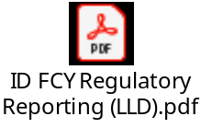

*NOTES: in case for Telegraphic Transfer for import payments (payment from Indonesia for goods import to Indonesia), see additional regulatory reporting called SiMoDIS in the next page.

- Non-IDR Regulatory Reporting – For Import Payment (named: *SiMoDIS)

*SiMoDIS : Sistem Informasi Monitoring terIntegrasi Seketika

Purpose Code for SiMoDIS (Sistem Informasi Monitoring terIntegrasi Seketika)
This field can be used to provide the following codes:

/XXX/2012//invoice1(invoice1_amount)invoice2(invoice2_amount)

Where:
/XXX/ = Purpose code for specific countries (i.e. Malaysia, China CNY). No need to provide this information if no regulatory requirements from the beneficiary countries
2012// = Purpose code for Import
Followed by all invoices with format invoice_number(invoice_amount) for that payment.
Note: invoice is free format and invoice_amount is numerical

General Rules:
- invoice is alphanumeric including symbols
- invoice_amount is numerical only
XML v3.0
<CdtTrfTxInf><RmtInf><Ustrd> : Unstructured
Rules:
- Total characters that can be provided in this fields is 105 char (Including 2012//)
- Do not use slash (/), at 36th and 71st character
- If the total character exceed 105 char, provide plus ‘+’ sign after the last invoice. Also, the last invoice and amount information cannot be cut in the middle. So, the complete information should be moved to the supplement message (manual form).

Example:
<CdtTrfTxInf>
…..
<RmtInf>
<Ustrd>2012//invoice1(invoice1_amount)invoice2(invoice2_amount) …</Ustrd>

For SiMoDIS example please see below table :

Sample 1
Total Invoice information less than number of character limit mapping (i.e. 4 invoices)

<CdtTrfTxInf>
…..
<RmtInf>
<Ustrd>2012//invoice1(invoice1_amnt)invoice2(invoice2_amnt)invoice3(invoice3_amnt)invoice4(invoice4_amnt)</Ustrd>

Sample 2
Total Invoice information less than number of character limit mapping (i.e. 8 invoices)

<CdtTrfTxInf>
…..
<RmtInf>
<Ustrd>2012//invoice1(invoice1_amnt)invoice2(invoice2_amnt)invoice3(invoice3_amnt)invoice4(invoice4_amnt)+</Ustrd>
*remaining invoices and amount information must be provided in MT199 with manual form.with below format:
+2012//invoice5(invoice5_amnt)invoice6(invoice6_amnt)invoice7(invoice7_amnt)invoice8(invoice8_amnt)

Sample 3
The payment is only for “group invoice” (i.e. only 1 invoice as representative of total transfer 1,909,473.67)

<CdtTrfTxInf>
…..
<RmtInf>
<Ustrd>2012//group-invoice(invoice1_amnt) </Ustrd>

Additional Information :

Below is additional information related to payment file development

No. | Information | Document
1 | Indonesia SWIFT & Bank Code  Note :  This bank code list can be updated at any time by Indonesia Central Bank | 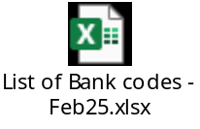
2 | Asia Purpose Of Payment Formatting  Note :  In this PDF document contain Crossborder Regulatory Reporting that applies for incoming payments on certain country | 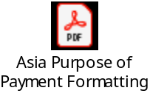
3 | Payment Advise Samples  Note :  - Free text only (PDF Format & Email)  - Free text & Tables (PDF Format & Email) |   Free Text Only    Free Text & Tables

THE END

